**Restaurant Management System**

**Agile Scrum Project**

Q1) Make a product backlog of user stories for the given case study. User Stories should be in the format of As a <type of user>, I want <goal> so that <reason>

Ans) The product backlog of user stories for the given case study is listed below.These are some examples of **User stories** of Restaurant Management System which are in product backlog:

1. As a user I want starters to be added in a Menu Page
2. As a user I want soups to be added in the Menu Page
3. As a user I want Main Course to be added in Menu Page
4. As a user I want Desserts to be added in the Main Page
5. As a user I want drinks to be added in the Menu Page
6. As a user I want to see the Search Bar Navigation
7. As a user I want that View Bill option should be there in the UI of Restaurant Management System
8. As a user I want that Table reservations would be done by Managers only
9. As a user I want that the Management would be able to view the reports at the end of the day
10. As a user I want that there has to be one payment gateway on the system
11. As a user I want that automated system must generate the Bill
12. As a user I want that Feedback form has to given to every customers of Grill House

These are some examples of **Epics** of Restaurant Management System.The epics examples are listed below:

a) **Menu Page**-This epic represents the Menu Page of the Restaurant Management System

of Grill House

b)**Bill Generation**-This epic represents the Bill Generation of Automated Restaurant Management System

c) **Table Generation**-This epic represents the table reservations

d) **Reports Generation-**This epic represents the reports generation

e)**Feedback Form-**This epic represents the feedback form

Here are the screenshots of the Product backlog items in Jira

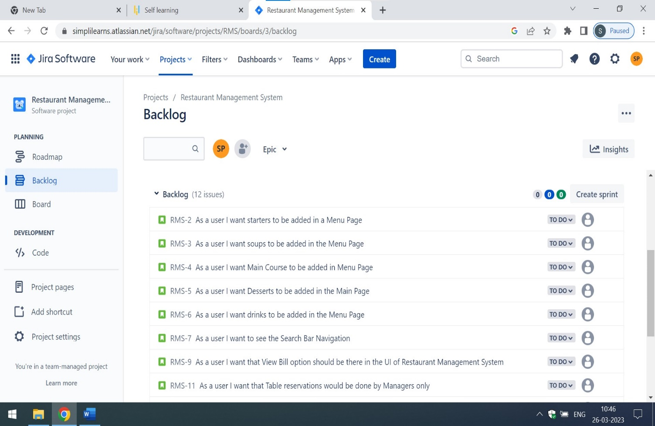

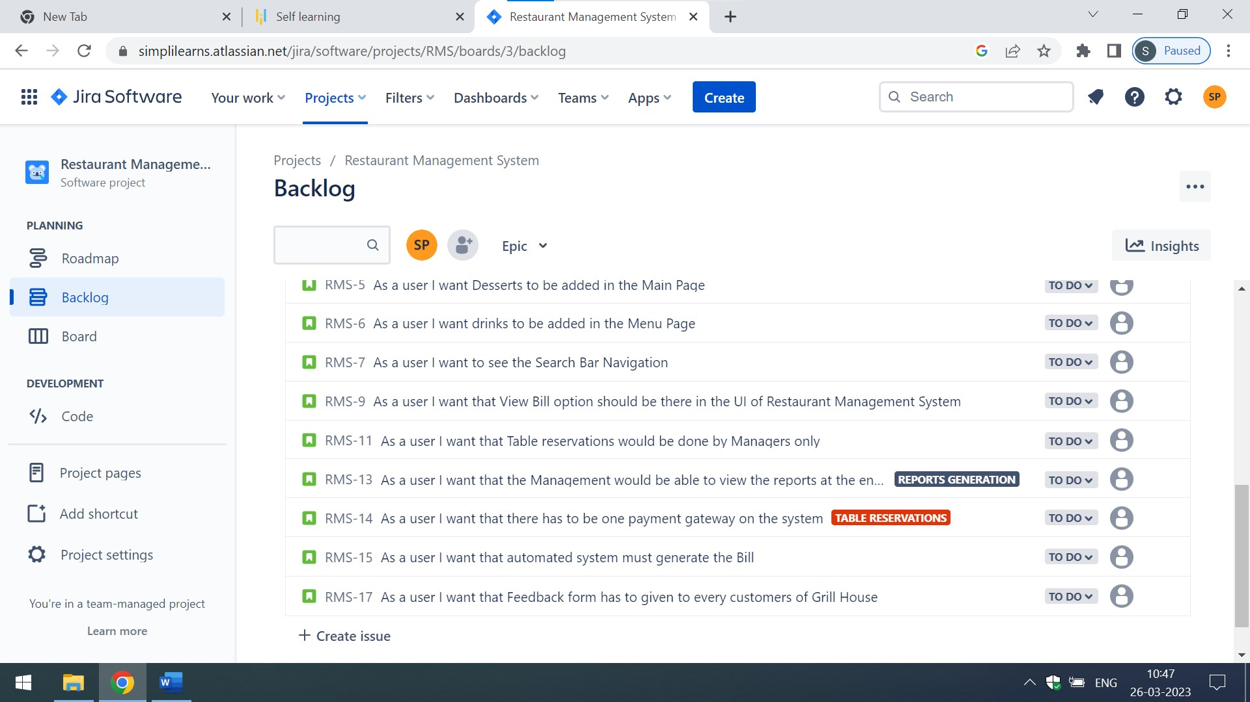

Here are the screenshots of Epics of Restaurant Management System in Jira

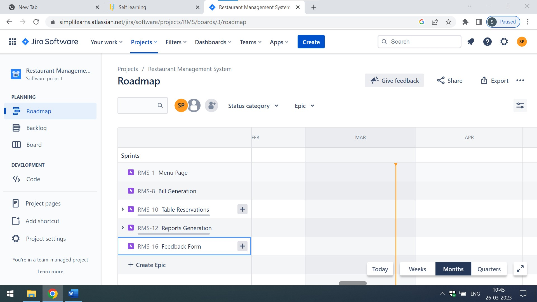

Q2) For each story write the acceptance criteria

Ans) These are the **Acceptance criteria of Menu page**

1. The starters must contains the Pasta,Sticky Baked Chicken Wings and Carmelized Onion Dips in the menu along with the prices in dollar notation
2. User can select multiple or single starter while placing the order
3. User/Customers must be able to edit the orders of starters before placing it

These are the **Acceptance criteria of Bill Generation Page**

1. There should be one drop down of bill generation in view bills which is accessible to Waiters of Grill House USA only
2. The bill must contains the customer information such as Name,Location,Mode of Payment and Address in a tabular format
3. Every bill shall be tagged to the waiter generating it and the table number
4. The automated restaurant Management must generate the bills for each customers in a tabular format
5. The bill should also contains the information such as Name, [S.no](http://S.no),Location and Purchase items in a tabular format
6. The bill must also have the signature of customers

These are the **Acceptance Criteria of Table Reservation Page**

1. The Managers would be able to select minimum 1 Guests and Maximum 15 Guests for table reservations
2. Their must be a specific time slots from 11:00 A.M to 11:00 PM given to managers for table reservations from customers
3. The waiters shall look into the software to determine which tables need to be reserved
4. There has to be one payment gateway in automated Restaurant Management for accepting the payments through cash or cards by the customers of Grill House

These are the **Acceptance Criteria of Reports Generation Page**

The report must has individual columns of

-Total sales of the day by dine in customers

-Total sales of the day by home delivery customers

-Total sales of the day (home delivery and dine in customers consolidated)

-The top 10 most sold dishes for the day

-Date wise view of Total Sales in every weekend

-Date wise view of Total Sales in every month

-List of dishes which are not sold in current month

-Total sales across all cities

-Total sales for each city

Here,I am attaching the screenshots of the **Acceptance criteria of Individual User Stories**

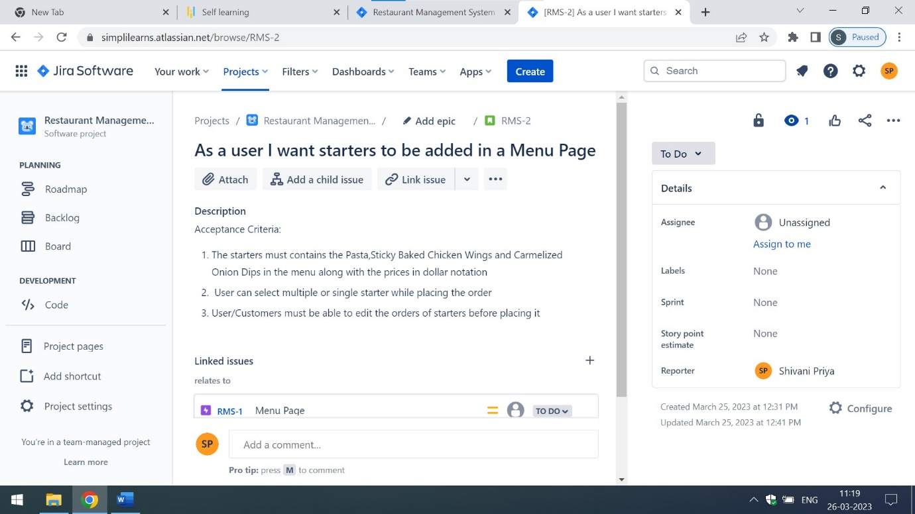

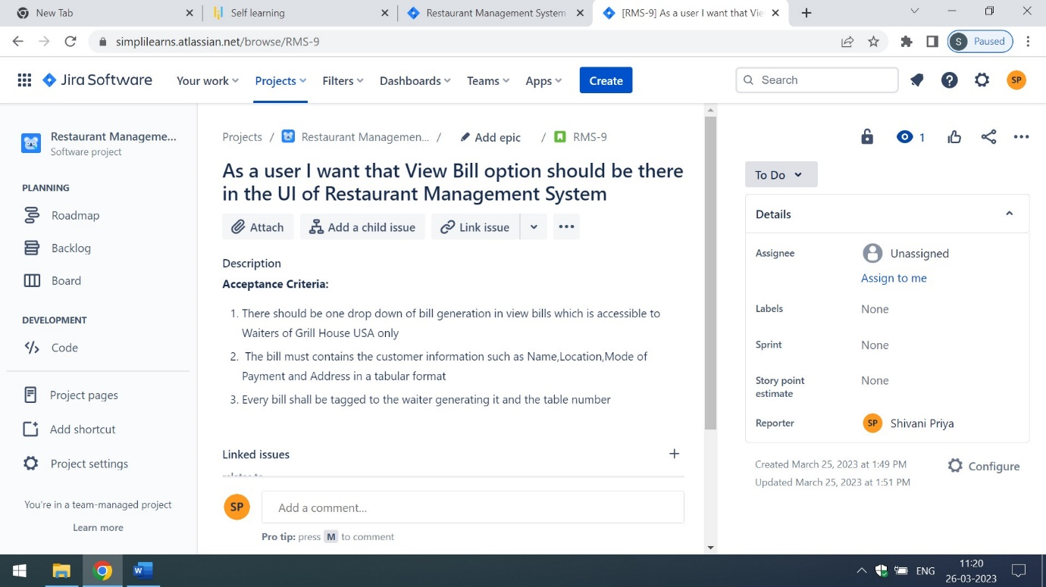

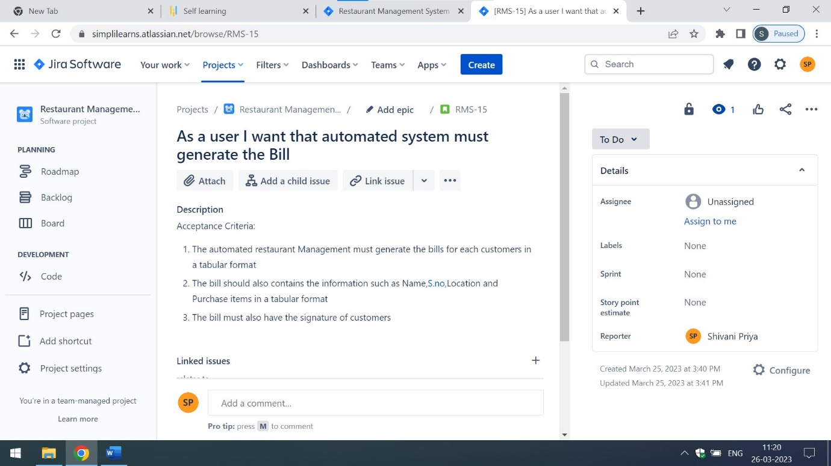

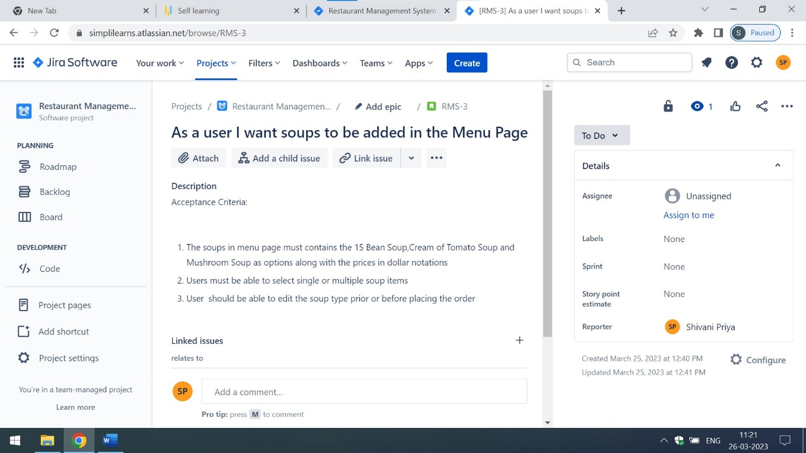

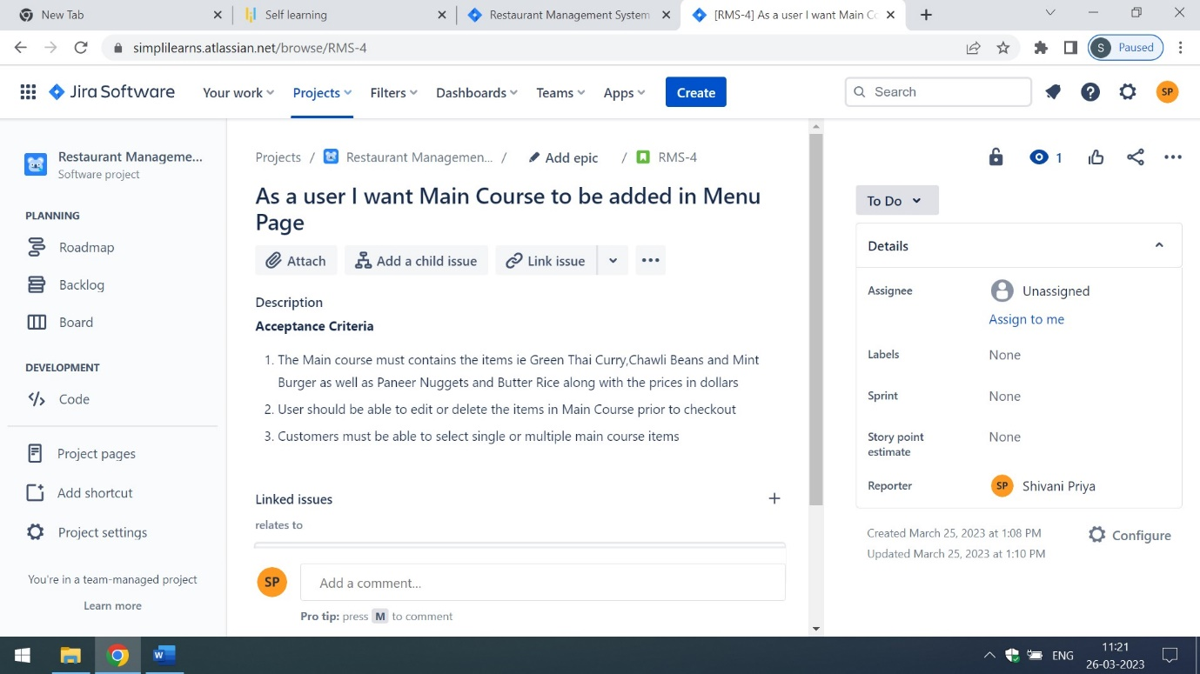

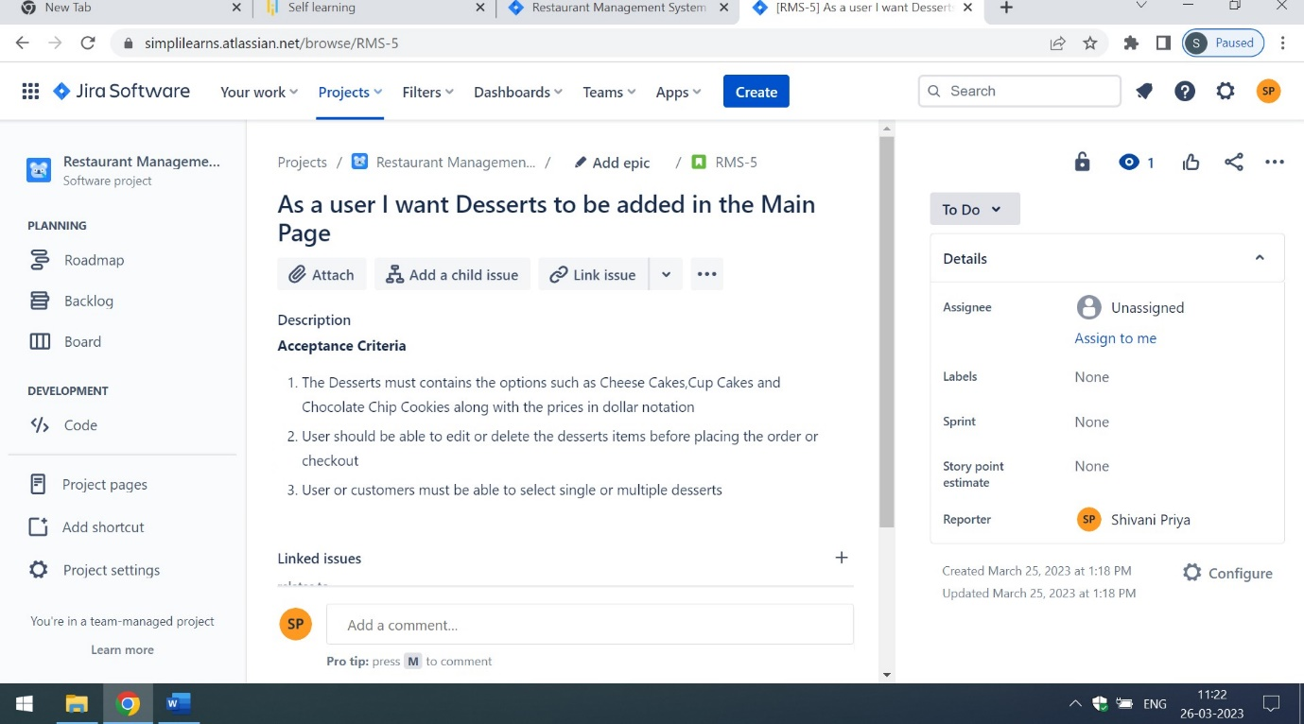

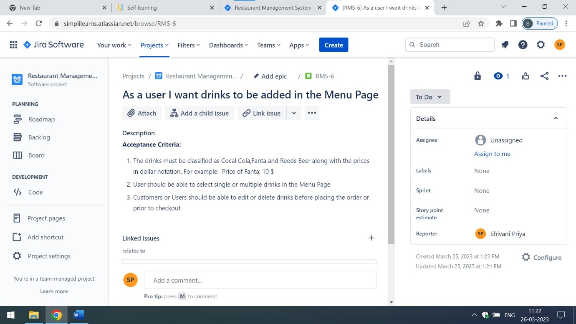

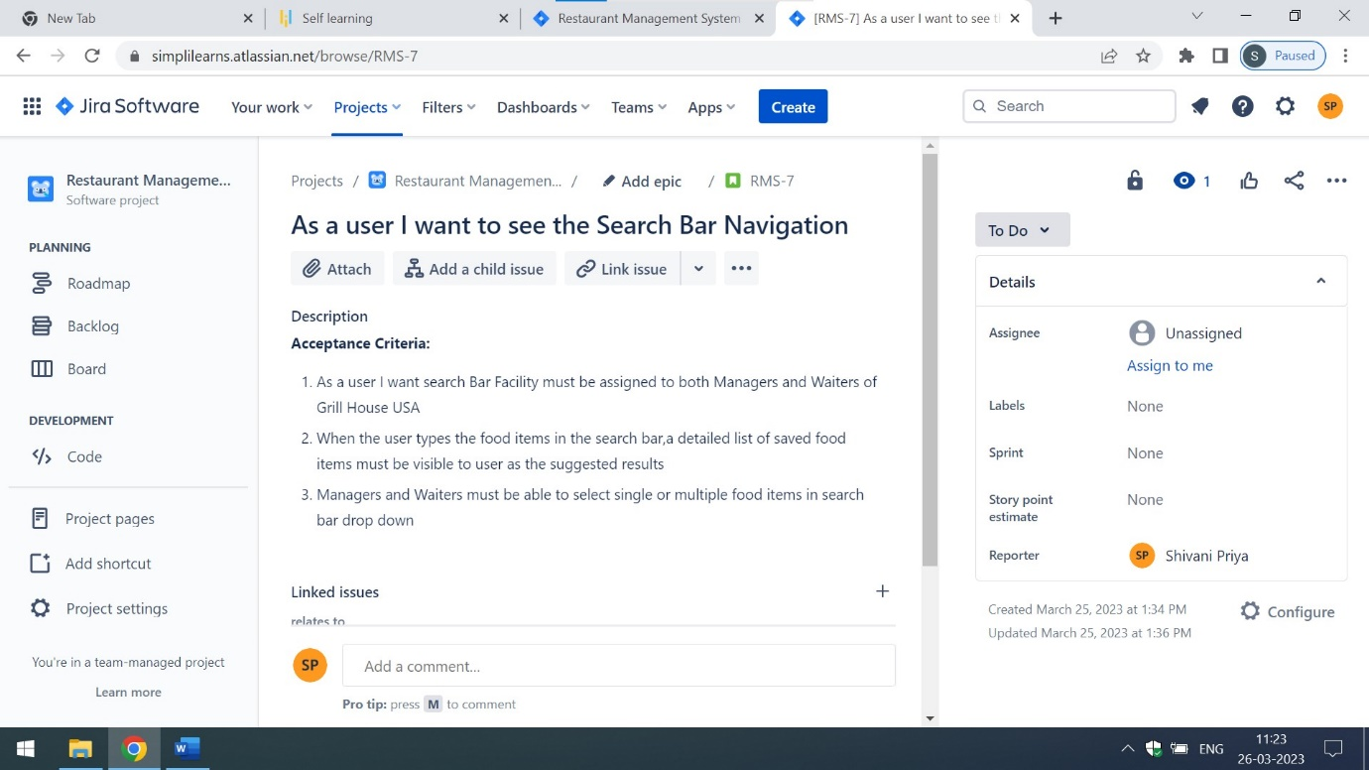

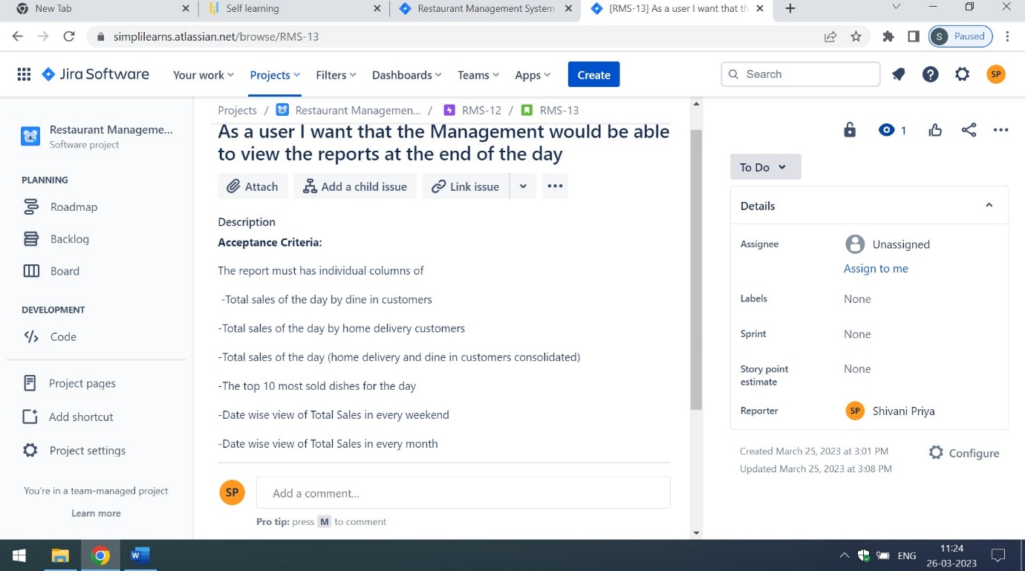

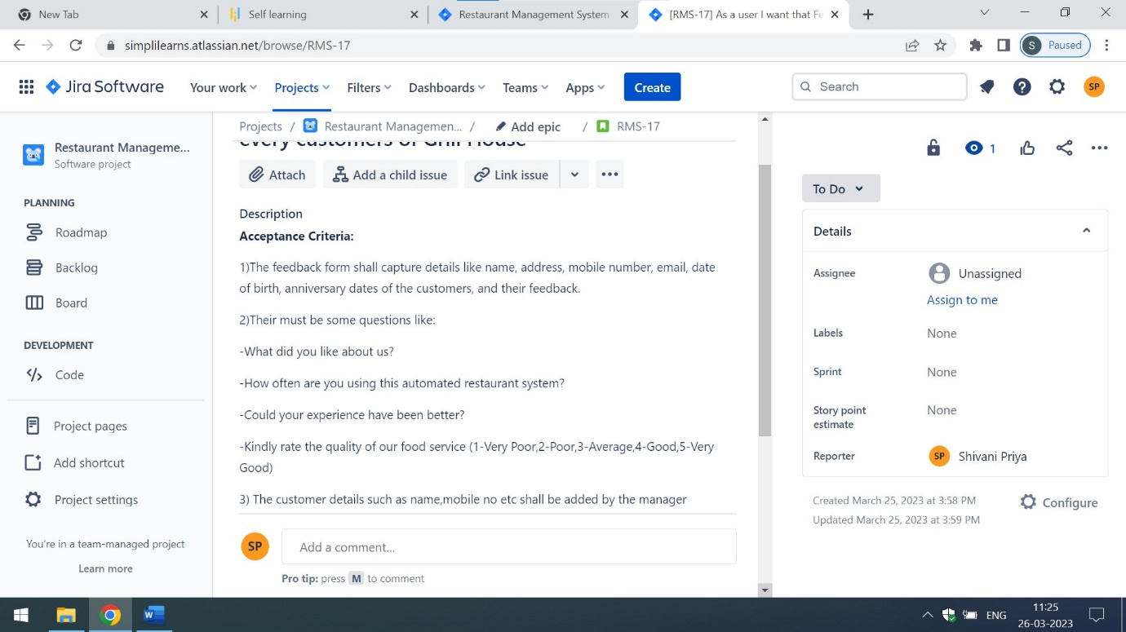

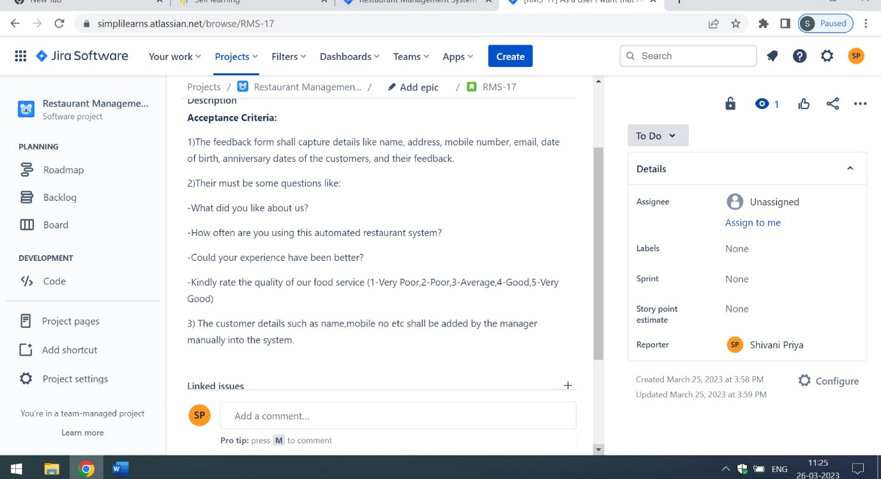

For detailed information of Restaurant Management Project System in JIRA. Kindly click on the below mentioned links:

* 1. <https://simplilearns.atlassian.net/jira/projects>

Click on Restaurant Management System

* 1. [https://simplilearns.atlassian.net/jira/software/projects/RMS/boards/3/roadmap](https://simplilearns.atlassian.net/jira/software/projects/RMS/boards/3/roadmap" \o "Epics of Restaurant Management System)

(For Viewing the Epics in Jira)

* 1. [https://simplilearns.atlassian.net/jira/software/projects/RMS/boards/3/backlog](https://simplilearns.atlassian.net/jira/software/projects/RMS/boards/3/backlog" \o "Backlogs of Restaurant Management System)

(For Viewing the Backlogs in JIRA)